RESEARCH AND DATA VISUALIZATION PORTFOLIO

Elaine Reiche, PhD, LAT, ATC, CSCS [elaine.reiche@gmail.com](mailto:elaine.reiche@gmail.com) | (512) 923-2011

Content

Automatic assessment and processing of drop vertical jump data 2

Emotional processing after orthopedic injury 3

Neurocognitive single leg hop performance and psychological readiness 4

Visual attention metrics are critical indicators of single leg hop performance after ACL reconstruction 5

Selected Manuscripts, Abstracts, and Digital Media 6

**Other Example Works (Links to OneDrive)**

1. [EEG Data Wrangling, Analysis, and Visualization in R](https://1drv.ms/u/c/327cf0e57c68d234/ESOsCJ2od4NOmFzFO6smYx8BKdQaKnJR5M370lpxF5fPuQ?e=XrdvSz)
2. [Mentee Research Poster](https://1drv.ms/p/c/327cf0e57c68d234/EbJxnRk_IK5IiSDcVdv6eFQBiFCnnTp7QIRloXK2yBlDmA?e=ocwjGM)

The Open Landing Error Scoring System (OpenLESS) is a novel development aimed at automating the LESS for assessment of lower extremity movement quality during a jump-landing task. A software package, “OpenLESS,” was developed to interpret movement quality (LESS score) from kinematics captured from markerless motion capture. Current projects include automating Loadsol data processing, analysis, and eventual synchronization of OpenCap and Loadsol data to collect field based kinematic and kinetic data.

OpenLESS: 92 participants (72 females and 20 males, mean age 23.3 years) from healthy, post-anterior cruciate ligament reconstruction (ACLR; median 33 months since surgery), and amateur athlete cohorts. The OpenLESS system showed excellent reliability and strong agreement with expert scoring for both healthy individuals and those recovering from ACL reconstruction. It drastically reduced scoring time, completing 159 trials in under 15 minutes compared to 18.5 hours for manual scoring. OpenLESS also performed reliably in real-world conditions, with consistent results across repeated sessions.

Data Collection: OpenCap, Vicon, Loadsol; Processing and Analysis: Python

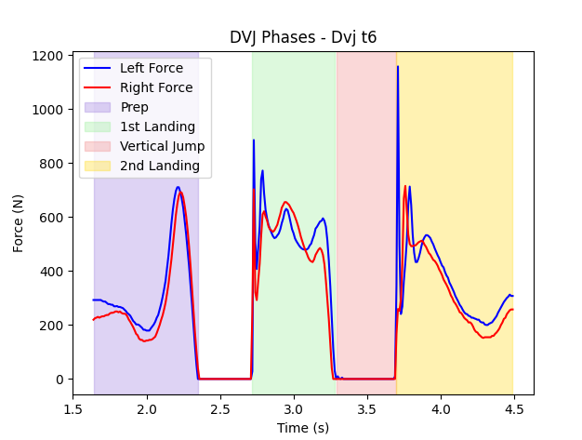

Figure 1. Automatic phase detection for drop vertical jump using Loadsol in shoe sensor data.

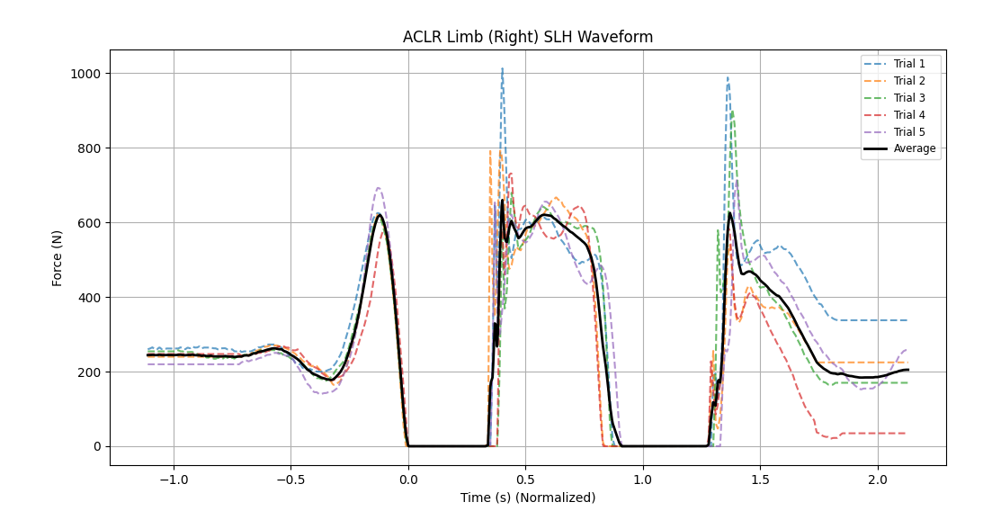

Figure 2. Time normalized DVJ waveforms.

Loadsol processing code available at: <https://github.com/reicheel/loadsol>

This script allows for easy cropping of loadsol data based on detected phases, automatic peak and impulse calculations for first and second landings, and generation of waveforms for each limb.

The goal for this project is to provide freely available tools for clinicians and researchers to collect and process biomechanical data with affordable tech.

Turner JA, **Reiche ET**, Hartshorne MT, Lee CC, Blodgett JM, Padua DA. Open Source, Open Science: Development of OpenLESS as the Automated Landing Error Scoring System. <https://www.medrxiv.org/content/10.1101/2024.11.28.24318160v1> Submitted to the Journal of Athletic Training November 2024.

Females after ACL reconstruction had **similar emotional processing** of images of actions that could induce potential knee injury and images of clear non-sport related threat. This population may subconsciously perceive sport activities as harmful or threatening, which may **explain the increased risk** of secondary ACL injury.

EEG was completed on 9 females (age = 21.4 ± 4.8 years [range: 14-35], time since surgery = 27.2 ± 13.9 months [range: 4-60]). Participants were instructed to view the pictures and EEG activity was recorded and the late positive potential (LPP) was measured in response to all images using the mean voltage within the 400-1000 millisecond time window following stimuli presentation. Difference in LPP amplitude across all conditions was examined.

Data Collection: NeuroScan Curry; Processing: MATLAB, Analysis: R. Data Visualization: MATLAB, R, STATA

Figure 5. Sport Image Example and LPP

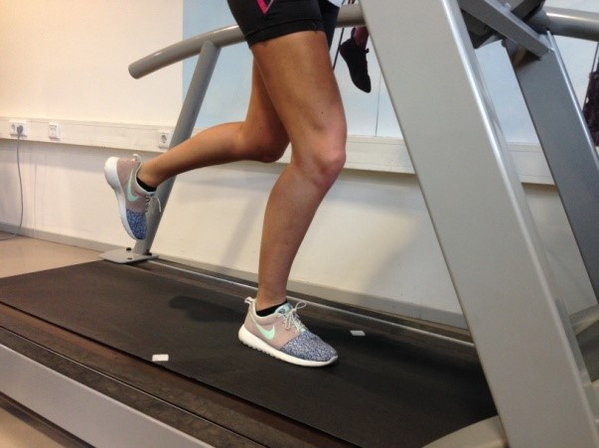

Figure 4. Non-Sport Image Example and LPP

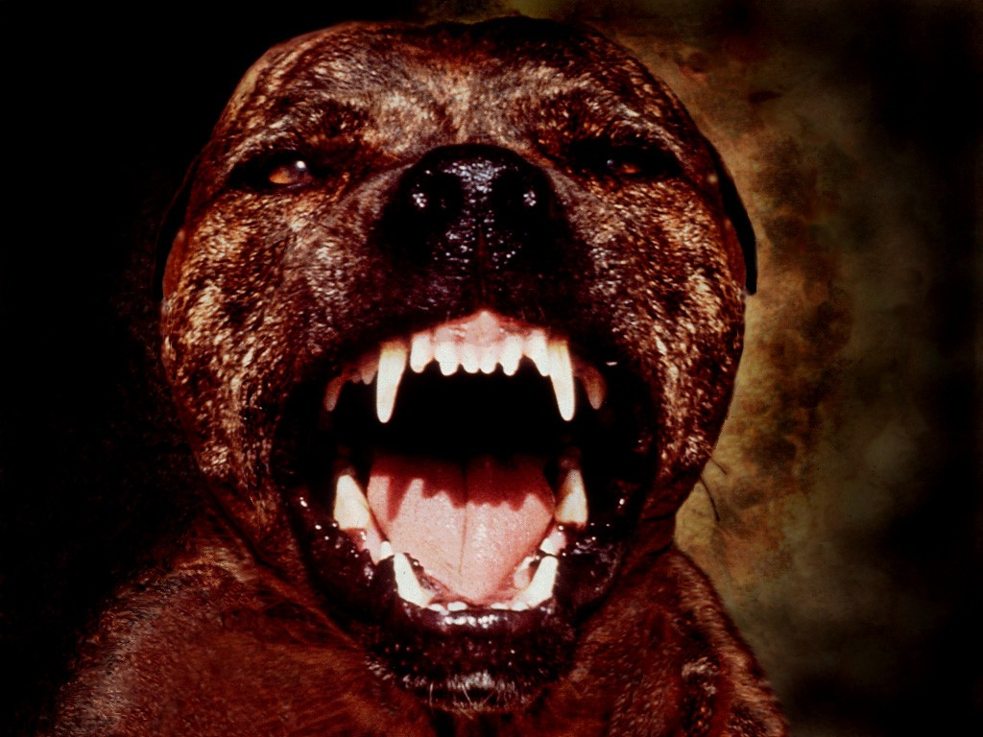

Figure 3. Late Positive Potential Amplitude Across Conditions

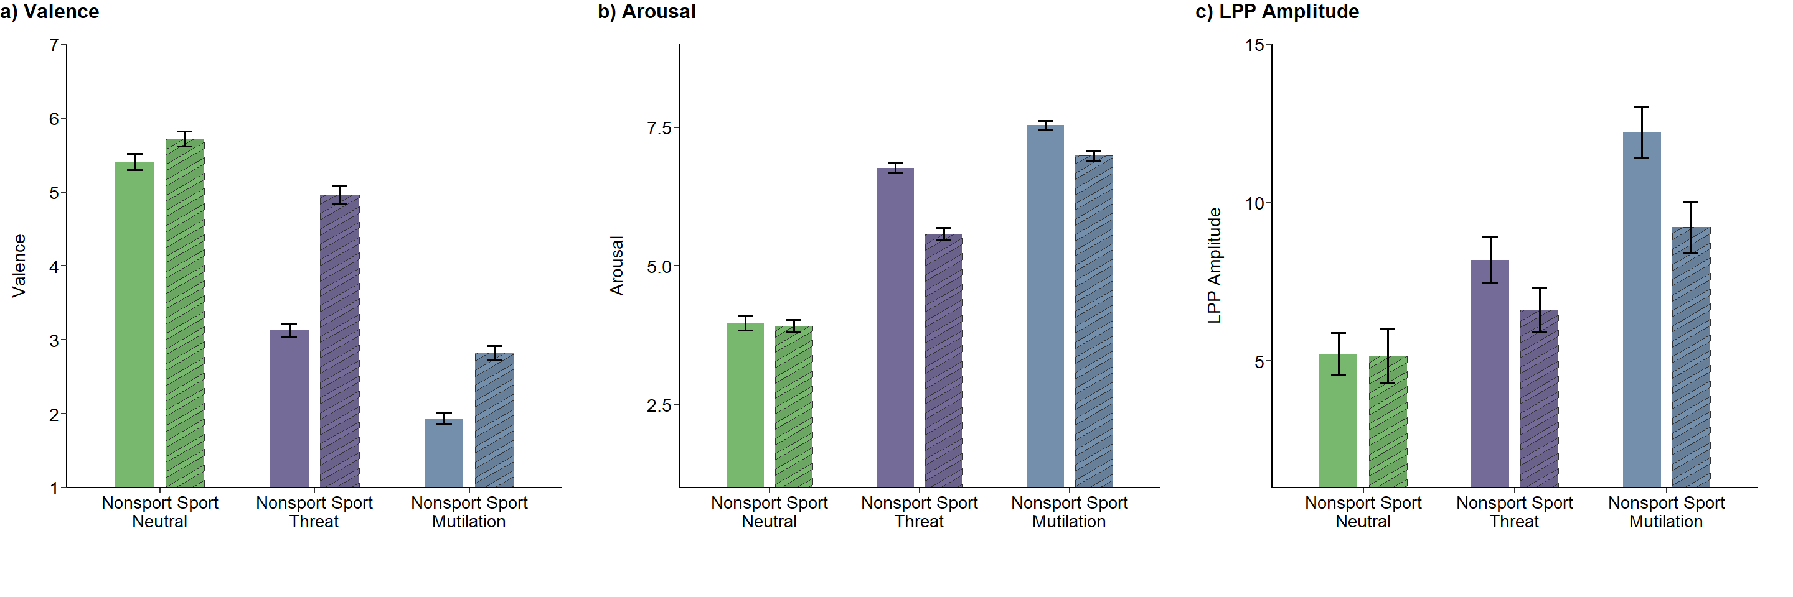

No differences in LPP amplitude between threatening non-sport (left) and sport images (Figure 3). Spectral power analysis shows an increase in intensity (lighter colors) over the LPP time period (Figures 4 & 5, bottom). Following ACLR, individuals appear to exhibit similar neural processing of images of actions that could induce potential knee injury and images of clear non-sport related threat, despite rating such images to be less arousing and more pleasant than non-sport-related threat images (Figure 6).

This graph highlights how different types of stimuli (conditions) evoke distinct emotional responses, with minor influences of context (sport or non-sport) on the distribution of ratings. Valence refers to the emotional quality of a stimulus (fear, sadness vs. happiness). Arousal refers to the intensity of the emotion (calm, relaxed vs. excited, fear). This study was a proof of concept to investigate emotional responses after orthopedic injury.

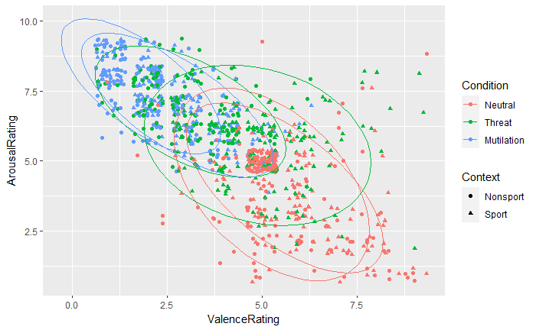

Figure 6. Valence and Arousal Ratings for Each Condition and Context

[Stimulus Presentation Script (Python)](https://1drv.ms/u/c/327cf0e57c68d234/EbzVHznEVWVKlIIl-TPqI-EBV4BxOt-cDqmKt7fIHlQS_g?e=seR7MN)

**Reiche ET**, Chandler MC, Coffman CA, Pontifex MB, Baez SE. No difference in emotional response between threatening sport and non-sport images in individuals following ACL reconstruction. Accepted as Rapid-Fire Platform Presentation at American College of Sports Medicine 69th Annual Meeting. May 2023.

Single leg hop (SLH) distance and psychological readiness are useful screening tools for return-to-activity assessments. Neurocognitive hops provide an anticipatory component that has been used to simulate sport specific scenarios. psychological readiness (measured by ACL-RSI Total Score) is a more significant predictor of single-leg hop performance for the ACL-reconstructed limb compared to the contralateral limb.

22 individuals cleared to return to sport with a history of primary, unilateral ACLR (17 females, time since surgery (TSS)=25±21 months, 1.7±0.1 m, 75.6±14.4 kg) were included. Neurocognitive SLH was assessed with two light-emitting sensors (Fitlight Trainer™). The stimulus light was positioned 3 meters in front and the timing light was 30 centimeters lateral to the starting line to record reaction time (ms). The Anterior Cruciate Ligament Return to Sport after Injury (ACLRSI) was used to evaluate psychological readiness with higher scores indicating ideal readiness to return to activity (ACLRSI > 76.6).

Data Collection: FitLight, OpenCap; Processing: R, Analysis: R. Data Visualization: R, STATA, Microsoft BI

Figure 7. Neurocognitive Single Leg Hop Distance vs Psychological Readiness

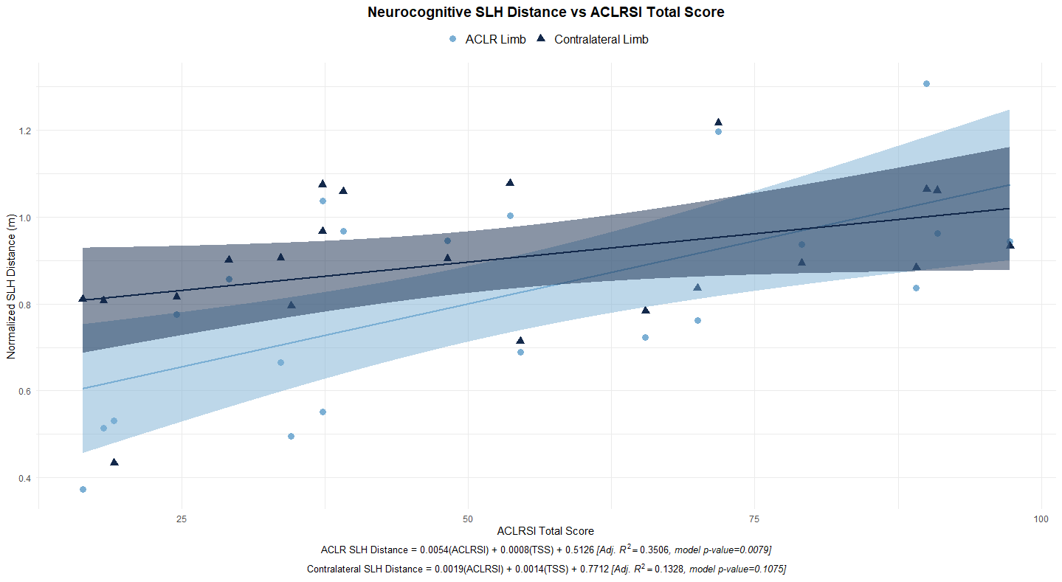

The stronger relationship for the ACLR limb highlights the importance of psychological readiness in functional recovery and performance after ACL reconstruction. For the contralateral limb, the weaker relationship may suggest that factors other than psychological readiness (e.g., physical conditioning or symmetry) play a larger role in determining hop performance.

**Reiche ET**, Willoughby D, Armitano-Lego C. Relationship Between Single Leg Hop Distance and Psychological Readiness During a Neurocognitive Task Following ACL Reconstruction. Accepted at American College of Sports Medicine 70th Annual Meeting. May 2025.

Microsoft BI Dashboard to quickly visualize performance data for testing sessions.

Visual attention plays an essential role in complex movement tasks after ACL reconstruction. Eye-tracking data (fixation duration and fixation location) offer actionable insights into attentional strategies, providing an objective lens into movement success or failure. Notably, successful hop performance is associated with longer fixation durations and a more task-relevant fixation strategy. Psychological factors, such as anxiety and depression, disrupt gaze behaviors, further impacting motor control and readiness for return to activity.

**Fixation Duration**: Longer fixation duration correlates with successful hop landings, indicating focused visual attention (red indicates longer duration).

**Fixation Location**: Concentrated gaze on the central task object (e.g., light) reflects task-relevant visual focus. In this error trial, dispersed fixations below the target suggest visual drift away from critical cues, potentially contributing to movement errors.

**Psychological Impact**: Elevated anxiety and depression symptoms are linked to changes visual sampling (shorter fixations, more frequent gaze shifts), potentially undermining physical performance.

Heat map (left) created in Python using Gaussian filter.

**Preparation and Landing Phases Are Critical**: Visual attention during the preparation and landing phases significantly impacts hop success. Earlier and longer fixations during these phases were associated with better outcomes.

**More Focused Visual Sampling Predicts Success**: Fewer, longer fixations (i.e., lower fixation count, longer fixation duration) were beneficial, suggesting that stable visual strategies support better neuromotor control.

Figure 8. Eye Tracking Heat Map for an Error Trial

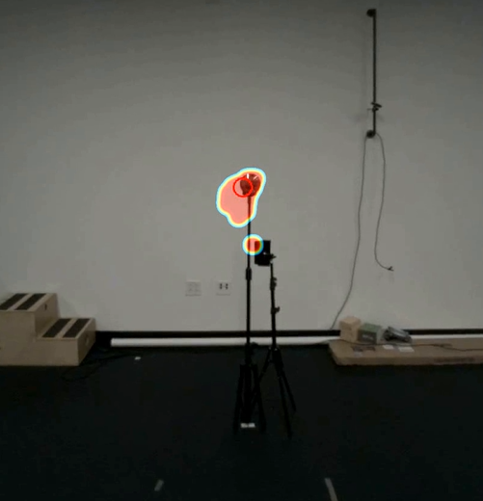

27 participants with a history of primary unilateral ACLR were included (19 female, 24.3 ± 5.1 years old, 36.4 ± 33.2 months since ACLR). Gaze behavior was assessed during the single leg hop task using wearable eye-tracking glasses (Tobii Pro Glasses 3). Fixations were defined as gaze held within 3° of visual angle for ≥100 ms, with fixation duration and count calculated per trial and motor phase. Fixation duration was normalized to single leg hop flight time (%). Linear mixed-effects models were applied to analyze the relationships between fixation duration and location during successful and unsuccessful single leg hop tasks for the ACLR and contralateral limb. Random intercepts were included to account for between-subject variability.

Data Collection: FitLight, Tobii Eye Tracking; Processing: R, Analysis: R. Data Visualization: R, Python

[Eye Tracking Heatmap in Python](https://1drv.ms/u/c/327cf0e57c68d234/ETh_mCmWIkZLlEEqiROV73ABRKCVMiYbaPBJRl14r_XEOA?e=xuQCEM)

# Selected Manuscripts, Abstracts, and Digital Media

## manuscripts

1. Turner JA, **Reiche ET**, Hartshorne MT, Blodgett JM, Lee CC, Padua DA. Open Source, Open Science: Development of OpenLESS as the Automated Landing Error Scoring System. <https://www.medrxiv.org/content/10.1101/2024.11.28.24318160v1>
2. **Reiche ET**, Collins KA, Genoese FM, Walaszek M, Triplett AN, Kuenze C, Harkey M, Baez SE. Lower Extremity Reaction Time in Individuals with Contact Versus Noncontact Anterior Cruciate Ligament Injuries After Reconstruction. *J Athl Train*. 8 January 2024; 59 (1): 66–72. <https://doi.org/10.4085/1062-6050-0428.22>
3. **Reiche ET**, Lam K, Genoese FM, Baez SE. Integrating Mindfulness to Reduce Injury Rates in Athletes: A Critically Appraised Topic. *Intl J Athl Ther Train*. 28(6), 291-298. <https://doi.org/10.1123/ijatt.2022-0138>

## abstracts

1. Liu M, **Reiche ET**, Kiefer AW. Fixation Duration and Location for Successful and Unsuccessful Single Leg Hop Performance in Individuals after ACL Reconstruction. UNC Undergraduate Research Day. April 2025.
2. Sorboro A, **Reiche ET**, Kiefer AW. Impact of Anxiety and Depression on Gaze Behaviors in Patients after Anterior Cruciate Ligament Reconstruction. UNC Undergraduate Research Day. April 2025.
3. **Reiche ET**, Willoughby DE, Armitano-Lago C. Relationship Between Single Leg Hop Distance And Psychological Readiness During A Neurocognitive Task Following ACL Reconstruction. Accepted for Poster Presentation at the 2025 American College of Sports Medicine Annual Meeting. Atlanta, GA.
4. **Reiche ET**, Genoese FM, Coffman CA, Pontifex MA, Baez SE. Self-Reported Knee Symptoms Influence Emotional Responses Post-ACL Reconstruction. National Athletic Trainers’ Association Clinical Symposia. New Orleans, LA. June 2024.
5. **Reiche ET**, Genoese FM, Brinkman CA, Baez SE. Multiple Object Tracking and Knee Symptoms In Healthy Controls And Individuals With ACL Reconstruction. American College of Sports Medicine Annual Meeting. Boston, MA. May 2024.
6. **Reiche ET**, Genoese FM, Collins KA, Walaszek MC, Harkey MS, Kuenze C, Baez SE. Kinesiophobia is associated with lower extremity perceptual-motor function after ACL reconstruction. National Athletic Trainers Association 2023 Clinical Symposia & AT Expo. June 2023. Indianapolis, IN.
7. **Reiche ET**, Genoese FM, Harkey MS, Collins K, Walaszek M, Triplett A, Kuenze CM, Baez. No differences in lower extremity visuomotor reaction time between patients with contact and non-contact ACL injuries. National Athletic Trainers Association 2022 Clinical Symposia. June 2022. Philadelphia, PA
8. **Reiche ET**, Collins KA, Genoese FM, Walaszek MC, Triplett AN, Harkey MS, Kuenze CM, Baez SE. Elevated injury-related fear is associated with greater knee abduction angle during jump-landing in individuals with ACL reconstruction. ACL Research Retreat IX: The Pediatric Athlete. March 2022. High Point, NC.

## Digital Media

1. [ACL and Return to Play](https://www.natafoundation.org/wp-content/uploads/Feb-2024-RTCP_ACL-Return-to-Play.pdf), NATA Foundation Research to Clinical Practice. Primary Contributor, reviewed by NATA Foundation Educational Resources Committee and NATA Foundation Board. February 2024.
2. [The ACL Injury Puzzle: Rethinking Athlete-Centered Care](https://simplifaster.com/articles/acl-injury-athlete-centered-care/), SimpliFaster Blog, reviewed by Rachel MacAulay (Editor) and Nathan Huffstutter (Managing Editor). October 2023.
3. [Sudden Cardiac Arrest](https://www.natafoundation.org/wp-content/uploads/RTCP-SCA_Feb23.pdf), NATA Foundation Research to Clinical Practice. Primary Contributor, reviewed by NATA Foundation Educational Resources Committee and NATA Foundation Board. February 2023.